QA Engineer Challenge

2. Load
For the load Test I have used Apache JMeter 2.13. It is an open source software, a 100% pure Java application designed to load test functional behaviour and measure performance
My previous experience with load tools were with company proprietary tolls from so I needed some extra effort to do some previous test with JMeter and to study the tool.

I’ve configured JMeter with:

- HTTP Request : IP Address, , end point and Json body
- CSV Data Set Config File with some input data (json data)
- HTTP Header Manager: Content-type/ application/json
- Constant Timer: Thread delay with value of 0,21 milliseconds
- Aggregate Report : To verify Throughput
- Resp. Times vs Threads: To verify Response time

All configurated details can be seen at folder
https://github.com/nanacleto/unbabel/Jmetter
    - unbabel_final.jmx
    - data_unbabel.csv

Because it is expected that
… this service must support 75 users at any given moment and must be able to handle 350 requests per second. The response time must be under 200 ms…

Having 75 Threads (users) and added a Constant Timer with a value of 0.21 milliseconds, this will totalize 75/0,21 = 357 request per second at any moment.
I’ve added not any Rump up Period, so the 75 users will be available at second 0.
Like this I could reach ~350 request per second and a response time ~200ms.

At the following print screen, you can see the Throughput about 340 request per second
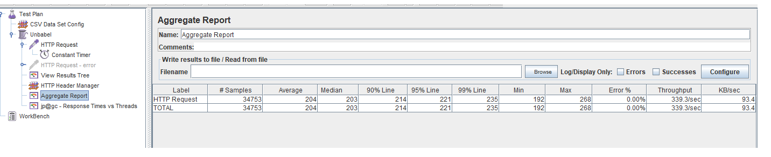

Bellow you can find the users/response time with a value of 205 ms.
Due to no rump up time, all user starts at same time. (Not usual at a normal “work daysituation”)
